CprE 381 – Computer Organization and

Assembly-Level Programming

Proj-B Report

Lab Partners Chimzim Ogbondah & Parth

Section / Lab Time Section 4: Th 4:10-6 pm

Submit a typeset pdf version of this on Canvas by the due date. Refer to the highlighted language in the Proj-B instructions for the context of the following questions.

- [Part 0] How are instruction and data memory initialized in the simulation? How does MARS interface with ModelSim?

- [Part 0] In the MIPS skeleton VHDL, how is a halting / termination condition detected? What MIPS assembly instruction does this correspond to?

- [Part 1 (a)] Modify the provided spreadsheet to include the list of M instructions to be supported in this phase alongside their binary Instruction OPcodes and Funct fields, if applicable. Create a separate column for each binary bit. Inside this spreadsheet, create a new column for the N control signals needed in your single-cycle processor implementation. The end result should be an M*N table where each row corresponds to the output of the control logic module for a given instruction. [You can attach the spreadsheet as a separate file, with a single spreadsheet for all Phase I and Phase II instructions.]

  - Attached in zip file

- [Part 1 (b)] Implement the control logic module using whatever method and coding style you prefer. Create a testbench to test this module individually, and show that your output matches the expected control signals from part 1a). [Please include waveforms and explanations.]
  - Control Unit. The waveform goes down the line of instructions starting with addi and ending on subu. ‘x’ is of type character in vhdl so x will also give a result of 0. For instructions that do not have a funct field their function field is set to x”3F”
  - 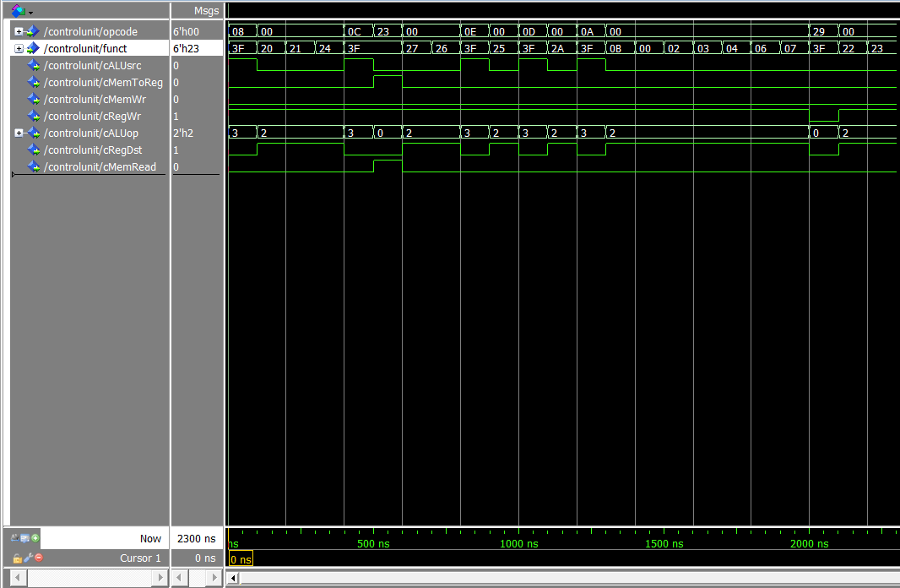
  - ALU control unit waveform follows the control unit starting at addi and ending at subu: Note that ShiftDir being high is for left shift and zero for right. LogArth high is 1 (Arithmetic) and low 0 (logical). Datapath being high is takes the barrel shift data whereas low takes the ALU data. Again “x” can’t be used since its of mismatching types
  - 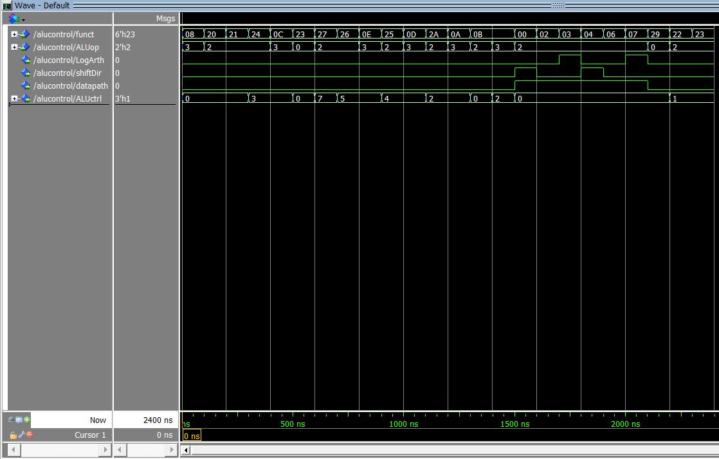

- [Part 2] In your writeup, provide your schematic for this part, describe what challenges (if any) you faced in implementing this module
  - NEED TO USE THE TOOLFOW GIVEN TO US AND THEN IMPLEMENT OUR OWN TEST BENCH THIS IS THE FULL DESIGN

- [Part 4 (a)] Describe these possibilities as a function of the different control flow-related instructions.
  - J (jump), jal (Jump and link), jr (Jump Register), beq (Branch on equal), bne (Branch on not equal) all these instructions have the ability to change the PC to a different value and so a Branch and Jump output from the control is needed in order to help support these instructions

- [Part 4 (c)] Update your processor schematic for the instruction fetch logic and any other datapath modifications needed for control flow instructions. In your writeup, describe what additional control signals are needed.
  - Again, as above since x isn’t of the right type it corresponds to a zero. The extra control signal that are need are Jump and Branch. This wave form starts at addi and ends at Jr (Jump register) just like the spreadsheet should
  - 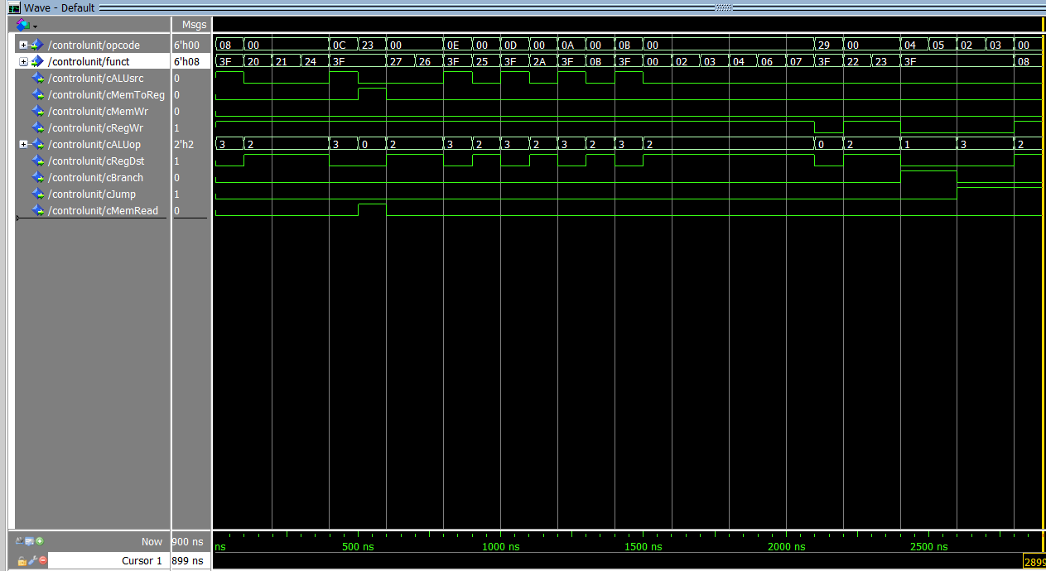

- [Part 4 (d)] Include ModelSim waveforms, and describe how the execution of the control flow possibilities corresponds to the waveforms in your writeup.

- [Part 5 (a)] In your writeup, show the ModelSim output for the individual instruction tests, and provide a discussion of result correctness. It may be helpful to also annotate the waveforms directly.

- [Part 5 (b)] In your writeup, show the ModelSim output for the Bubblesort test, and provide a discussion of result correctness. It may be helpful to also annotate the waveforms directly.

- [Part 5 (c) BONUS] In your writeup, show the ModelSim output for the Mergesort test, and provide a discussion of result correctness. It may be helpful to also annotate the waveforms directly.

- [Part 7] Report the maximum frequency your processor can run at and determine what your critical path is. Draw this critical path on top of your top-level schematic. In your writeup, briefly discuss your critical path results. What components would you focus on to improve the frequency?

- [Feedback] You must complete this section for your lab to be graded. Please complete each column separately for each team member; I expect it to take roughly 10 minutes (do not take more than 20 minutes).

  - How many hours did you spend on this lab?

Task | During lab time |  |  | Outside of lab time
Team Initials |  | co |  |  | co
Reading lab |  | 1 |  |  | 1
Pencil/paper design |  | 1 |  |  | 2
VHDL design |  | 5 |  |  | 4
Assembly coding |  | 0 |  |  | 0
Simulation |  |  |  |  | 2
Debugging |  | 1 |  |  | 2
Report writing |  | 0 |  |  | 1
Other:
Total |  | 8 |  |  | 10

  - If you could change one thing about the lab experience, what would it be? Why?
    - Having a better walk through our guide for how to use the testing tool flow it is very intimidating since we are all working virtually

  - What was the most interesting part of the lab?
    - Chimzim: combinational logic that went into the control unit

